PARISH OF MARK

The 2026 Annual Parish Meeting of Mark will be held in the Church Hall, Vicarage Road, Mark on Tuesday 3rd March 2026 at 7.00 p.m.

AGENDA

- Apologies

- Minutes of the 2025 Annual Parish Meeting to be presented and signed.

- Report of the Somerset Councillors

- To receive a report from Councillor D Kehoe, Chairman of the Parish Council, upon the work of the Parish Council during 2025/26.

- To receive information from Robert Stone, Agricultural Partner, Greenslade Taylor Hunt, on proposals to manage the land previously owned by the late Gill Isgar via an appropriate grass keep agreement.

- Public Question Time

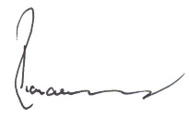
Richard Young
Clerk of the Council

24th February 2026

